ASBURY/SALMON HOUSE
Historical Overview

(1935-1945) Asbury Home

Cline and Harry Asbury left Winslow, Arizona in 1913. Prior to their move, Harry managed a refrigeration plant for the York Engineering Company. The brothers relocated to Phoenix, Arizona. There, Harry founded, and Cline managed the Crystal Ice and Cold Storage Company.

Thirty-one-year-old Cline Asbury and twenty-three-year-old Della Ritter met in 1918. They married in 1919. They had two children, Velma and Della. In 1926, they bought a house (since taken down) at 333 W. Moreland Street. Cline purchased a nine-plus acre tract of land, on Central Avenue, from Mrs. William J. Murphy. The property was seven miles north of the Phoenix City boundary. In 1930, Cline purchased a home (still standing at 91 W. Lynwood Street) from his brother Harry after Harry built a more prestigious residence (65 E. Country Club Drive) at the Phoenix Country Club.

Except for a citrus grove and a barn, the Central Avenue property remained undeveloped until 1934, when Mr. Asbury retained local architect L.M. Fitzhugh to design a new family residence. Cline hired builder Hugh Meadows to construct the Mediterranean Revival style home. They moved into their new home in September 1935.

Cline, Della and their two daughters lived in the house until 1942, when Cline died unexpectedly of a heart attack, at the age of 55. After his death, the estate proved to be a financial burden for Mrs. Asbury. She attempted to keep the property, but on December 15, 1945, Della Asbury sold her “dream home” to former Arizona Assistant Attorney General, Riney B. Salmon.

Della bought a smaller home, located at 309 E. Orange Drive. She lived in that house for nearly 40 years. In 1985, she moved to San Diego, California, to live with her youngest daughter. Della Asbury died in 2003, at the age of 107. Cline and Della Asbury are interred in Phoenix, Arizona, in the Greenwood Cemetery Encanto Mausoleum.

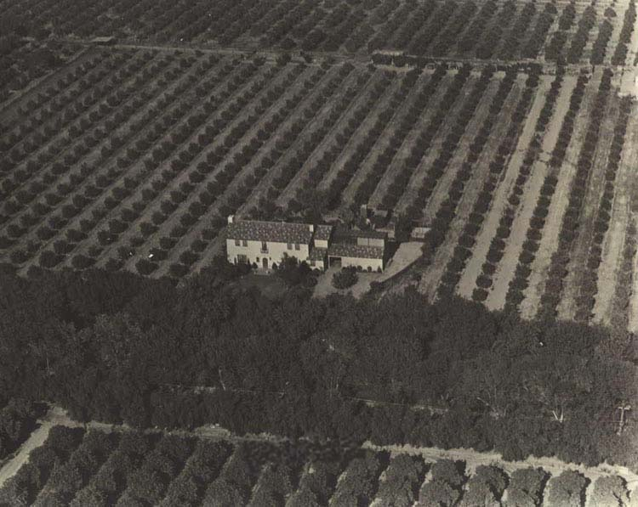
Asbury House (circa 1935)

(1945-1972) Salmon Home

In 1908, five-year-old Riney Salmon moved with his parents from San Angelo, Texas, to Bisbee, in the Arizona Territory. His father was employed by the Phelps Dodge Corporation. After he finished high school, Riney moved to San Diego, California, where he sold automobiles for a brief period. He returned home and enrolled at the University of Arizona. He worked summers in the blacksmith shop at the Bisbee mine. He was graduated from the University of Arizona Law School in1925.

Lorraine Polley was born in Bisbee on April 2, 1908, nearly four years before Arizona attained statehood. She grew up on a family owned ranch, 18 miles from Bisbee. She met Riney Salmon when she was a young girl. At the time, the Bisbee copper mine was still active. As Lorraine recalled, the town had a population of approximately 20,000.

After law school, Riney began a law practice in Bisbee. Lorraine and Riney were married in 1929. They moved to Phoenix that same year when Riney was named Assistant Attorney General of Arizona, during the administration of Governor George W.P. Hunt. In 1942, Riney joined with three other attorneys to form the law firm of Jennings, Strouss, Salmon and Trask. Lorraine and Riney had four children, Diane, Kay, Riney Jr. and Linda. They lived in the Phoenix Encanto district until 1945, when Riney bought the Central Avenue residence from Della Asbury.

Riney, Lorraine and their children moved into their new home in December 1945. From 1946 thru 1949, Mr. Salmon represented local landowners in their efforts to bring a safe and reliable water supply to the northernmost portion of the Orangewood Subdivision. In 1946, the Suburban Pump and Water Company agreed to install a main water line south from Northern Avenue to Orangewood Avenue, along both sides of Central Avenue. It took nearly three years to negotiate the deal and to install the line. Nine local property owners shared the installation costs.

In 1958, Phoenix mayor Jack Williams announced a plan to annex 38.2 square miles north of the city. Known as the “Sunnyslope Annexation,” the area included the Orangewood Subdivision. Water and sewer management came under city control. Riney was a legal expert on matters involving water rights. From 1963 to 1965, he served as chief counsel for the Interstate Stream Commission, involved in the Arizona-California dispute over Colorado River water.

The Salmon family lived in their Central Avenue home for more than 25 years, until 1970, when Mr. Salmon died of injuries received in an auto accident. At the time of his death, his firm was said to be the largest law firm in the state.

Two years later, 64 year old Lorraine remarried. In 1974, she subdivided her property. She kept the house and a 1.24-acre parcel for her family residence. She sold the other eight-plus acres to local builder/developer, Bill Goodheart. Thirty-five homes were built on the land that was once a part of the Asbury/Salmon property citrus grove. Lorraine lived in her home for another 28 years with her second husband, Jess Hawley.

(1972-2000) Hawley Home

The third, and possibly least recognized, steward of the Asbury/Salmon property was Jess Hawley. Jess E. Hawley was born on August 22, 1907. He was the youngest of eleven children. He spent his early years in a sod house on the Oklahoma plains. The son of a blacksmith, Jess learned the craft as he followed his father to numerous mines across the Midwest, in search of work. Jess was a self-educated man. He was endowed with a keen intellect, endless curiosity and a lifelong search for excellence.

Jess served his blacksmith apprenticeship in Indiana. He first married in 1931. Midwestern winter weather caused Jess serious health problems and he moved his family to Phoenix, Arizona, in 1933. The Hawley’s had two daughters, Janet and JoAnn. Jess started a blacksmith shop at his home at 833 N. 10th Avenue. He repaired medical equipment to feed his family while he established his business. He earned a reputation for quality work and integrity.

Jess became well known as a master blacksmith and machinist. He was also a skilled poet, author, photographer and inventor. He designed, and patented several pieces of medical equipment and machinery. He rebuilt or replaced many of the rural Arizona windmills that are still in use today. He taught blacksmithing classes to aspiring metalworkers and hobbyists. It was through one of those classes that he met Riney Salmon. Riney enjoyed working as a blacksmith’s helper during his college years, and, he took classes to improve his metalworking skills.

Through the years, the Salmon’s and the Hawley’s became friends. Jess’s wife, Ann, died two years before Riney’s unfortunate auto accident. After Riney’s death, Jess Hawley and Lorraine Salmon provided companionship for one another. Two years later, they married. Lorraine and Jess were married for more than 36 years, until May 17, 2009 when Lorraine, 101, passed away. Two months later, on July 14, 2009, Jess, 101, also died.

(2000-Present) Zaccaro Home

On March 23, 2000, Anne and Jim Zaccaro purchased the Asbury/Salmon house from Lorraine (Salmon) Hawley. Anne, Jim and their son Jonathan began a lengthy restoration effort. To date, the project has been underway for more than ten years.

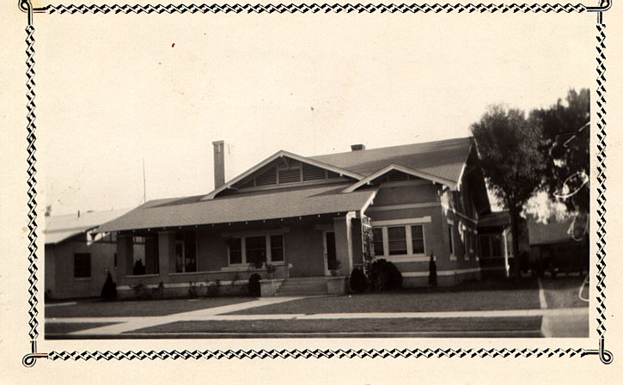
91 West Lynwood – 1924
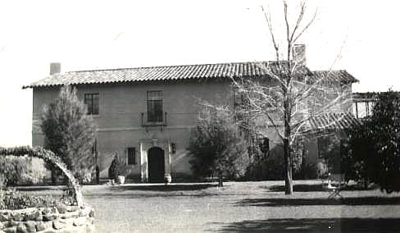
Asbury House - 1935
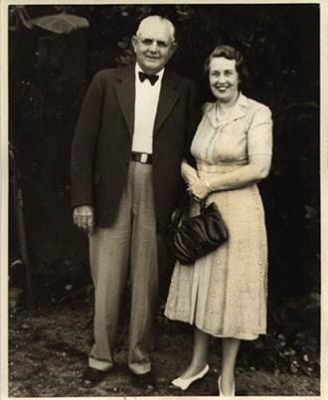
Cline & Della Asbury -1939
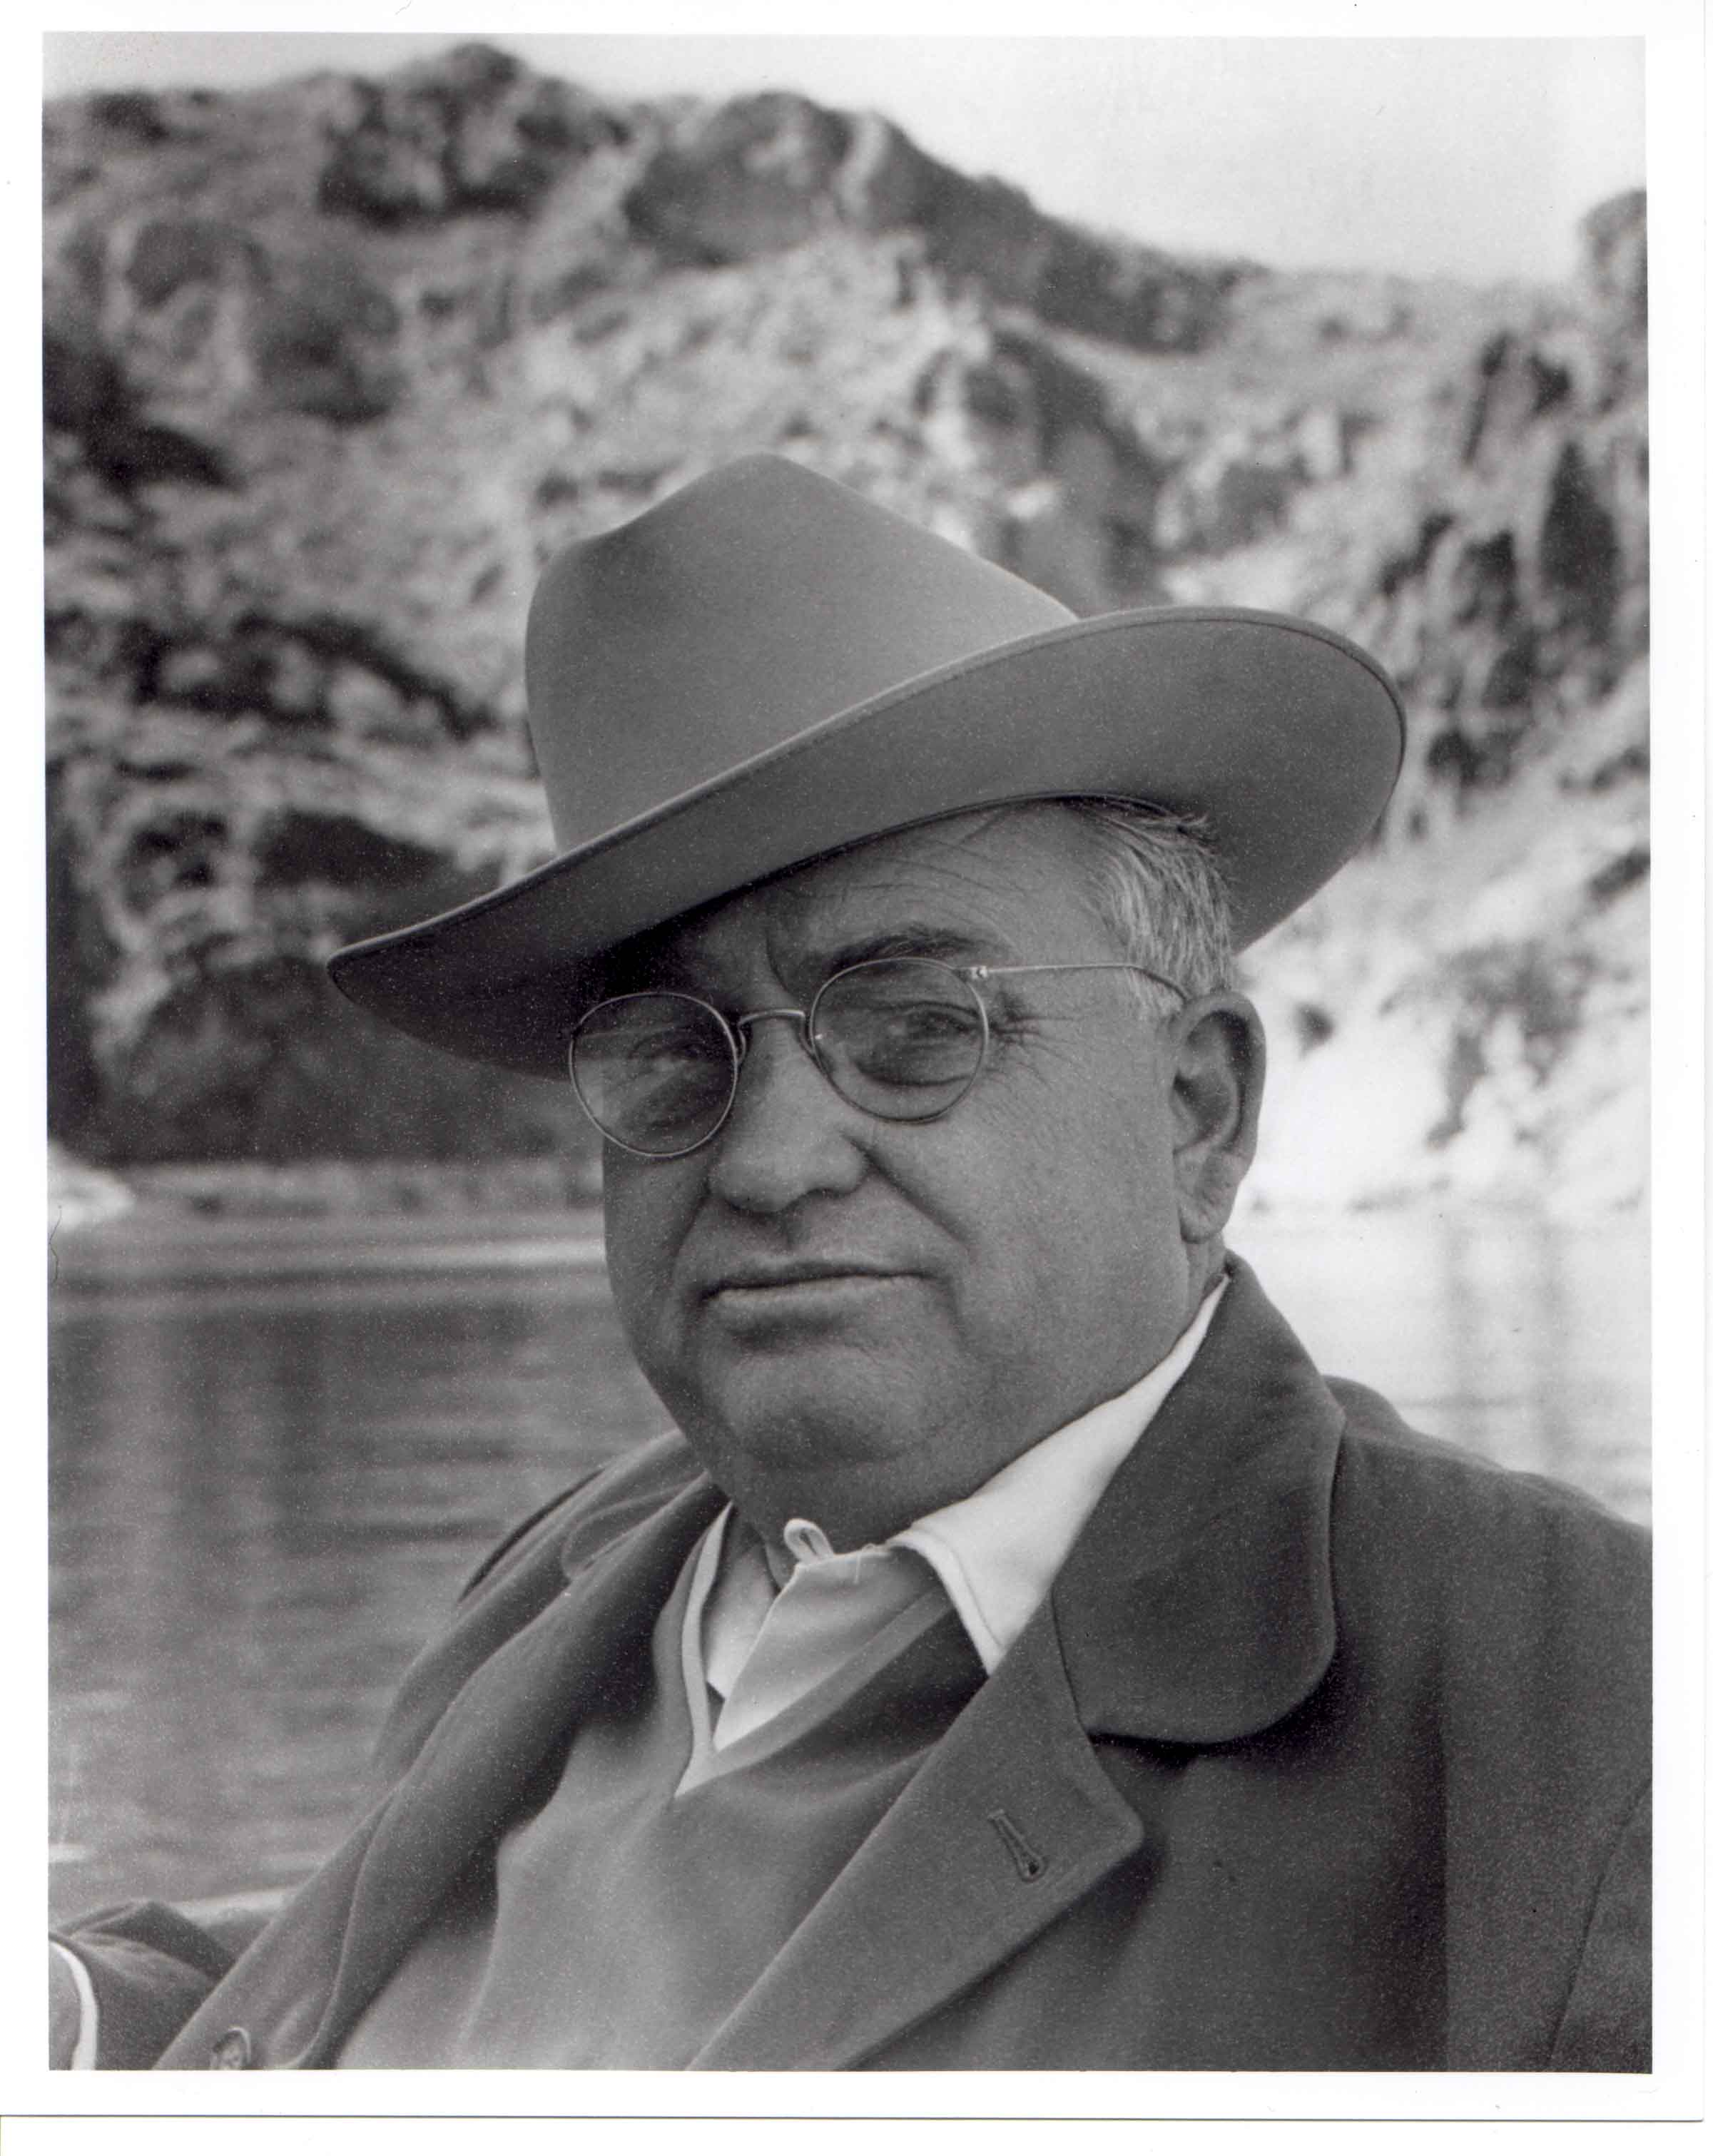
Riney Salmon - 1962
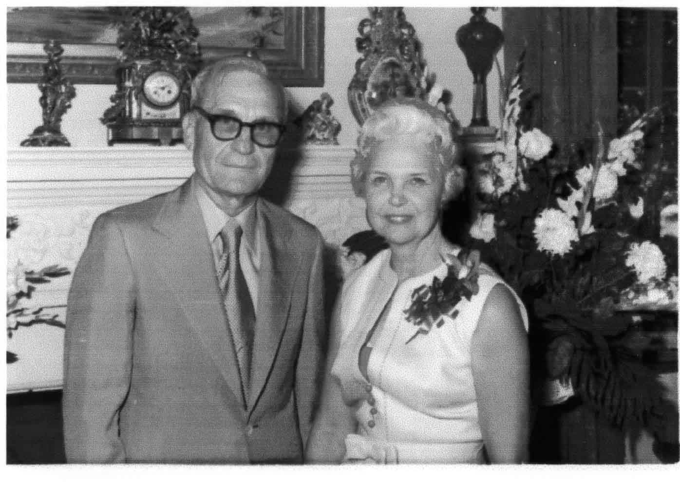
Jess & Lorraine Hawley - 1972

ABOUT THE PROPERTY

Historic Name: Asbury/Salmon House

Construction Date: 1934-1935

Architect: L.M. Fitzhugh

Builder: Hugh Meadows

Style: Romanticized Mediterranean Revival

Main House Garage, Shop, Guest House

Property: 1.24 Acres* Same
Building Size: 5000+ Square Ft. 4000+ Square Ft.
Construction: Concrete, Adobe Block, Stucco Concrete, Cement Block, Stucco
Roof Type: Gable - Clay Tile Gable - Clay Tile
Rooms: 19 + Basement 7 + Garage & Shop
Windows: Steel Casement - 44 (628 panes) Steel Casement - 16 (316 panes)
Doors: 9 Exterior, 29 Interior 8 Exterior, 14 Interior

* Subdivided in 1974 from original 9+ acre tract purchased from Mrs. W.J. Murphy in 1926

Featured Presentations

Magazine: “Liquid sunshine for Breakfast” Arizona Highways Volume XX,
Number 4, April 1944: 12-15

“On the Bridle Path” Phoenician Times Volume 1,
Number 3, April 2004: 5, 16

Internet: www.JVZaccaro.com Photos Page, July 2000 - Present

Phoenix Historic Preservation Register: Z-116-02-4, March 5, 2003

National Register of Historic Places: 10000154, April 8, 2010

Television: “If Walls Could Talk” HGTV Episode #1111, June, August 2004

“On The Issues” PHX 11 May 21, 2005

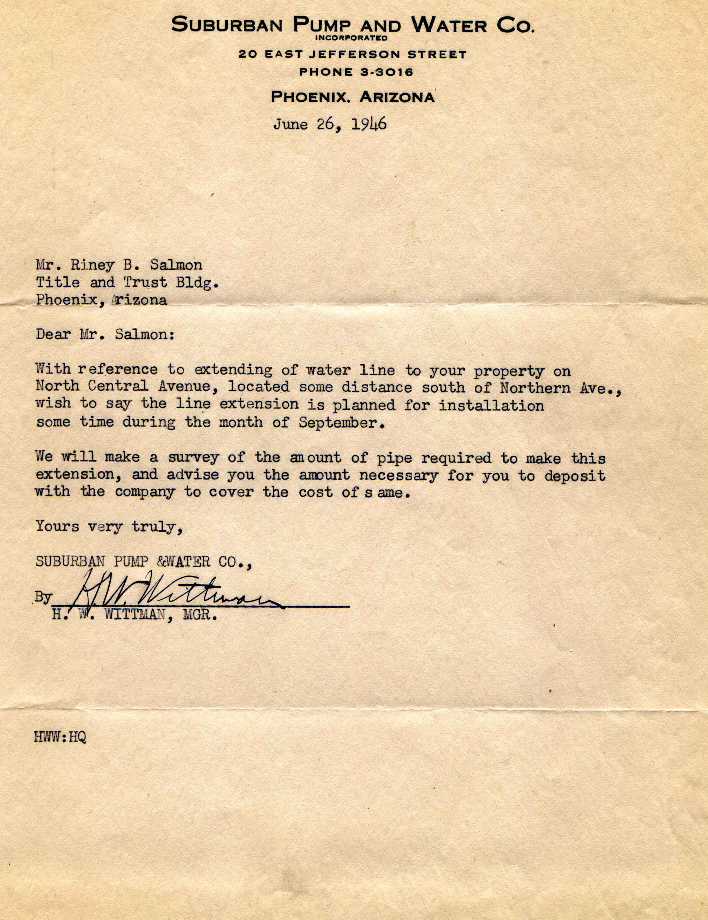

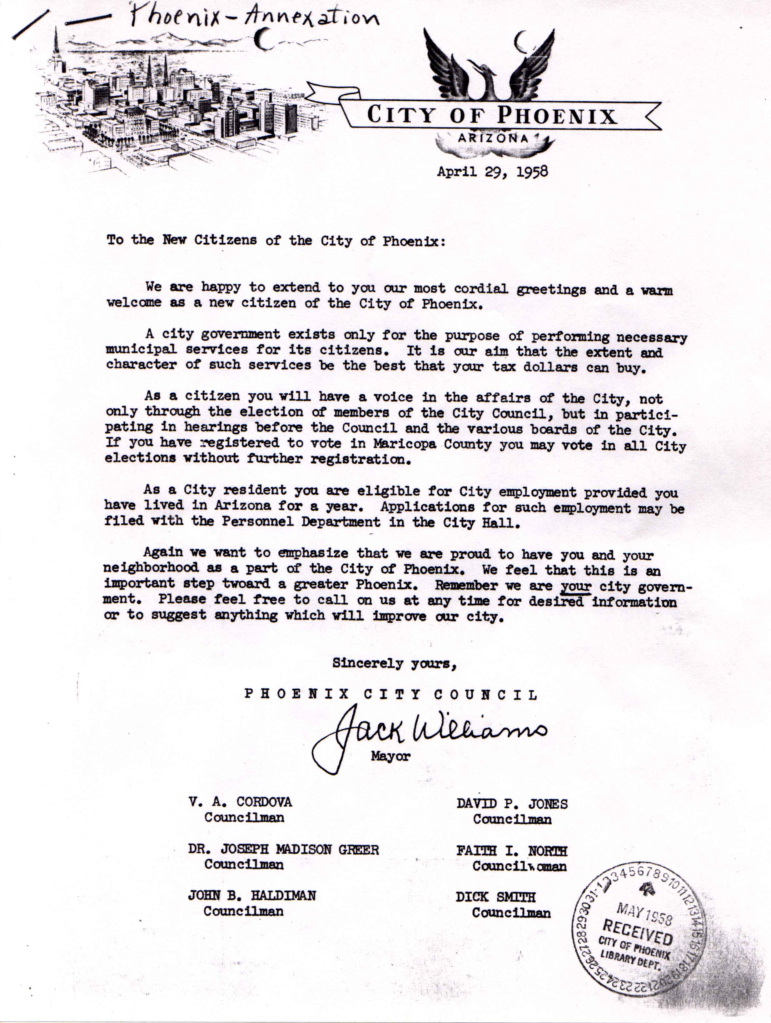

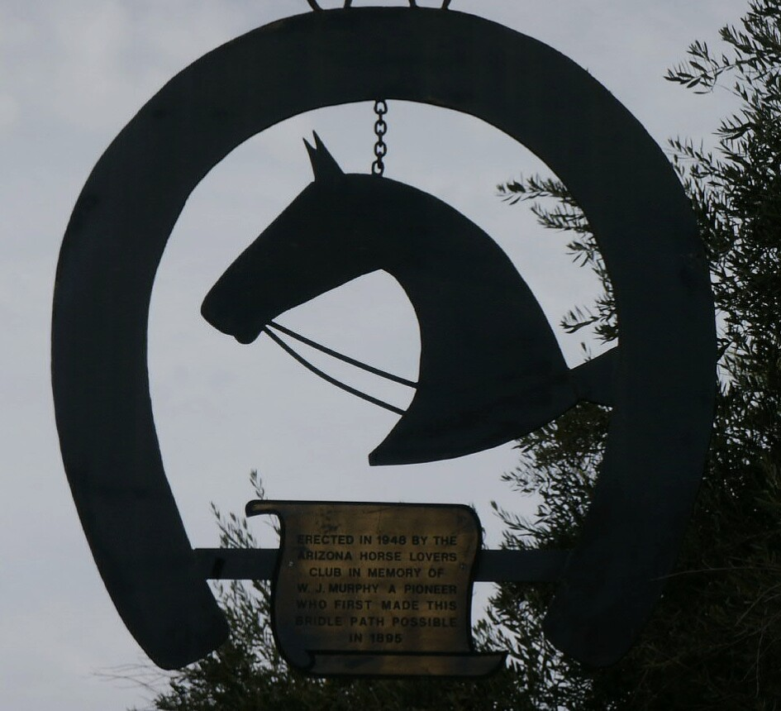

WILLIAM J. MURPHY
the
Murphy Bridle Path
and the
North Central Avenue Corridor

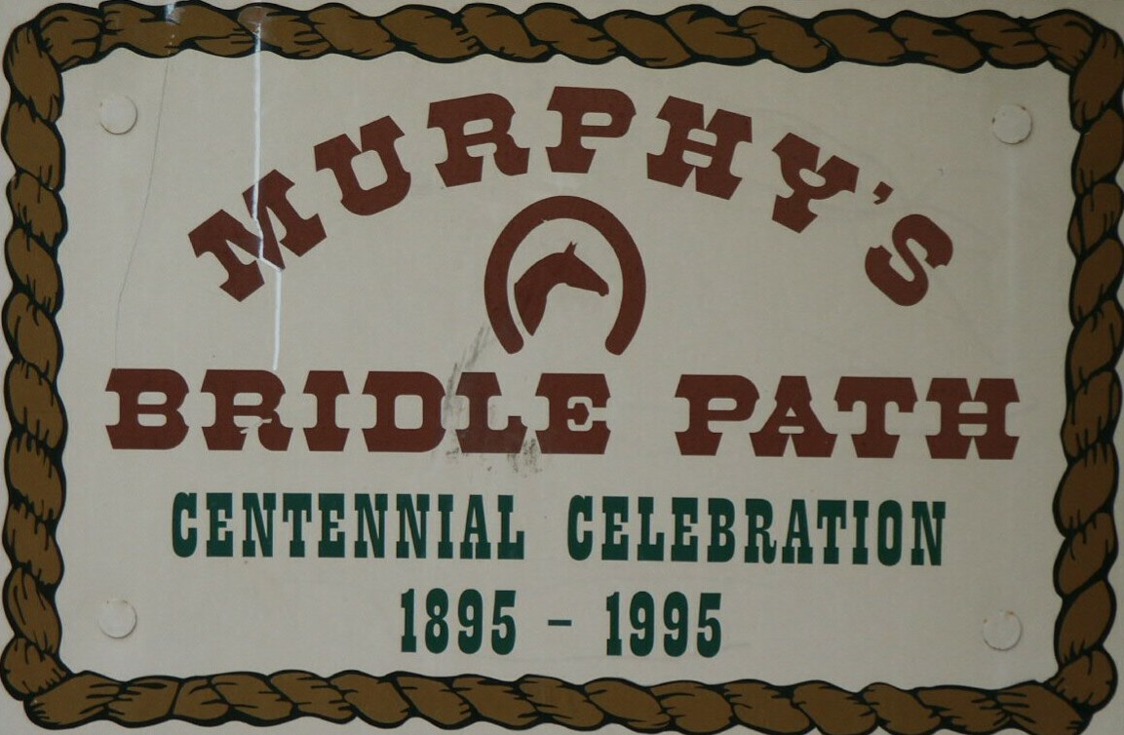

WILLIAM J. MURPHY
the
Murphy Bridle Path
and the
North Central Avenue Corridor

Historical Overview

William J. Murphy was born in New Hartford, New York, on August 23, 1839. He served in the Union Army during the Civil War. As the war drew to a close, Reconstruction began. The U.S. Government promoted development of the territories west of the Mississippi River. The Homestead Act of 1862* caused a mass migration to the West. The Pacific Railway Act of 1862 granted railroads enormous rights-of-way to establish train routes to the West coast. Railroad companies became the West’s largest landowners. Americans settled more than 430 million acres west of the Mississippi between 1870 and 1900.

Murphy came to Arizona in 1881 as a railroad contractor hired to build a section of the Atlantic and Pacific (Santa Fe) Railroad. In 1883 he contracted to construct the 44-mile long Arizona Canal. By the turn of the century, he had become a major local developer, heavily involved in regional banking and agriculture. Murphy was also responsible for the construction of Grand Avenue and for organizing the townsites of Alhambra, Glendale, Ingleside and Peoria.

Murphy viewed the Arizona Canal as an opportunity to bring extensive development to the area. He formed the Arizona Improvement Company. By 1895, he had acquired two square miles of land between, what is today, Bethany Home Road and Northern Avenue, from 7th Street to 7th Avenue, north of the city of Phoenix. The property was platted as the Orangewood Subdivision.

Mr. Murphy extended Central Avenue through his property. He added trees along both sides of the road to make the subdivision more attractive. He imported citrus trees from Southern California and planted them on his land. Today, the Murphy Bridle Path parallels the North Central Avenue extension that he undertook more than 110 years ago.

Murphy saw great potential in the valley and he brought his family to Phoenix. In 1898, he broke ground for a new family residence at the corner of Central Avenue and the county road (Orangewood Avenue). The three story Queen Anne style home was completed in 1900.

William Murphy and his wife Laura sold tracts of land in the subdivision throughout the remainder of his life. He died on April 17, 1923, at the age of 84. Laura Murphy sold out the remaining Orangewood Subdivision property following her husband’s death. By the time America entered WWII, the land in Orangewood had been sold. Laura devoted her energies to the citrus industry for many years after her husband’s death. Laura Murphy died on May 21, 1943, at the age of 97. The Murphy’s are buried in the Phoenix Greenwood Cemetery.

* Note:
The 1862 Homestead Act gave 160 acres of public land to anyone who paid a $10 registration fee and pledged to live on the land and cultivate it for a period of five years.

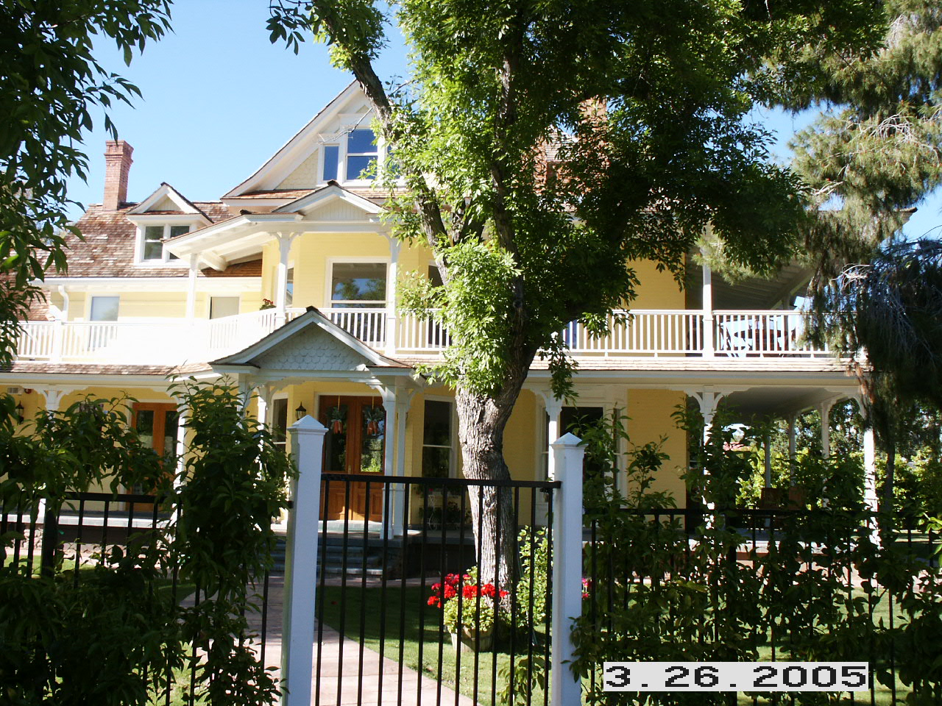

William J. Murphy House

The lack of safe and reliable drinking water limited growth in the Subdivision. Private water companies supplied drinking and irrigation water to properties outside Phoenix city limits. Water service to the area north of Orangewood Avenue was finally established in 1949.

The Past 50 Years

With a reliable water supply, Orangewood participated in the post WWII housing boom. In late 1958, Phoenix acquired the Orangewood Subdivision as part of a 38.2 square mile annexation, the largest since the city was incorporated in 1881. In the years that followed, many large properties were subdivided to create thousands of new homesites.

In 1991, one of the last large tracts in the Orangewood Subdivision was developed. The final 10 acres of the original Brophy estate (7601 N. Central) were sold. By 1993, that property had been developed as La Reserve, an upscale 36 unit Townhome project. In recent years, area property prices have soared. Smaller properties have come under increased pressure for redevelopment. In the process, a number of historically and architecturally important homes were destroyed.

In 1993, a North Central Corridor Estate Survey was conducted to identify architecturally and historically significant North Central Phoenix homes. Fifty-five structures were identified as desirable for preservation. Since that time, fourteen homes were lost to demolition. Six of the demolished buildings were Orangewood Subdivision residences. Of the remaining eligible properties, ten are Orangewood residences along North Central Avenue. On March 5, 2003, the Asbury/Salmon house was added to the Phoenix, Arizona, Historic Preservation register. On April 8, 2010, the property was added to the National Register of Historic Places, Registration Number 100000154.

Looking To The Future

Residential in-fill is inevitable. North Central Avenue land is attractive, valuable and conveniently located for those who travel into the central city. In-fill is not the issue. What is at risk is the loss of neighborhood character and integrity if haphazard redevelopment is allowed to take place. Since many homes in the Subdivision were built during the past 35 years, the area does not qualify for protection as an historic neighborhood.

REVISITING THE PAST

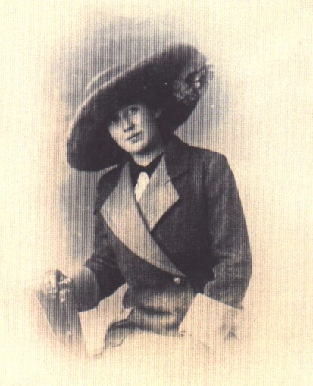
Della Ritter – 1918
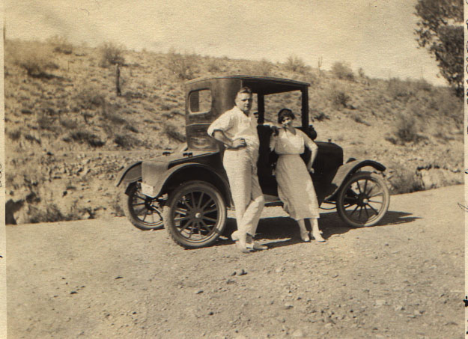
Cline & Della – 1921
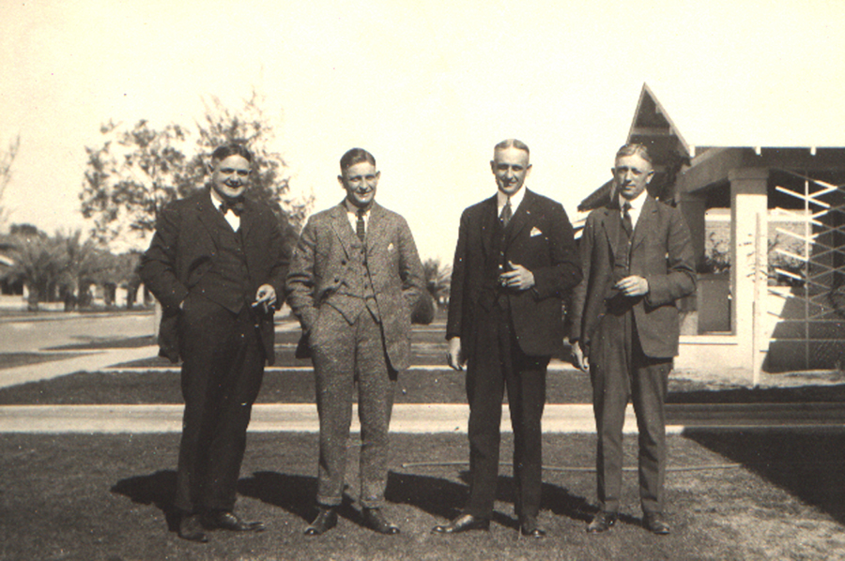
Asbury Brothers – 1924
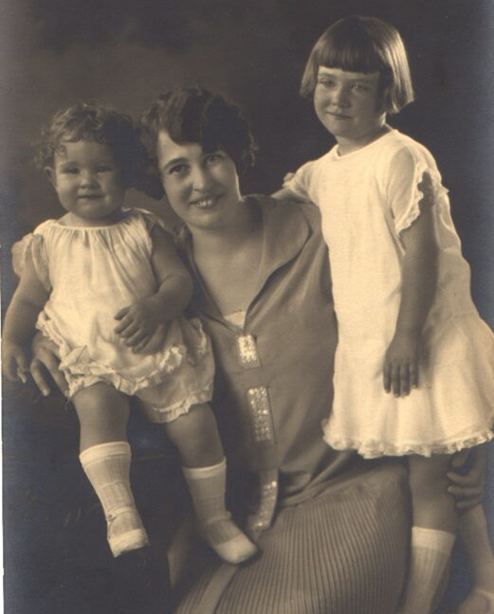
Della & Girls - 1926
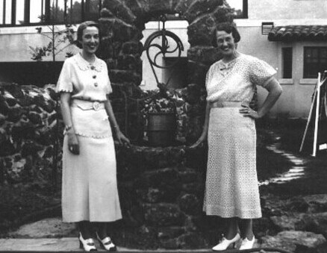
Della & Sister, Muriel - 1936

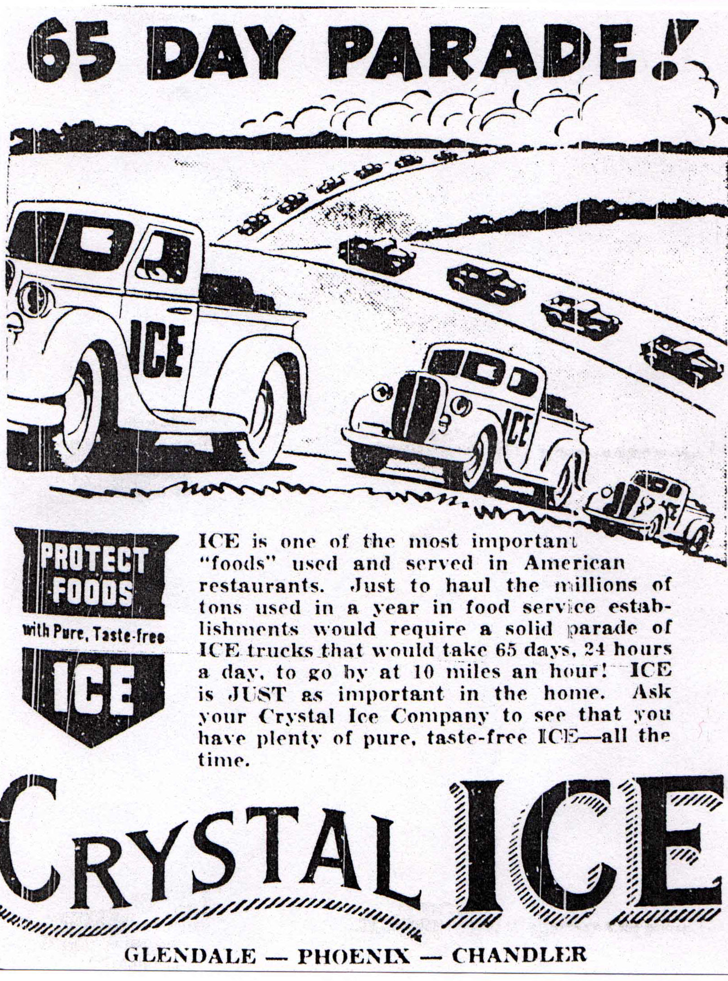
Crystal Ice Ad – 1938

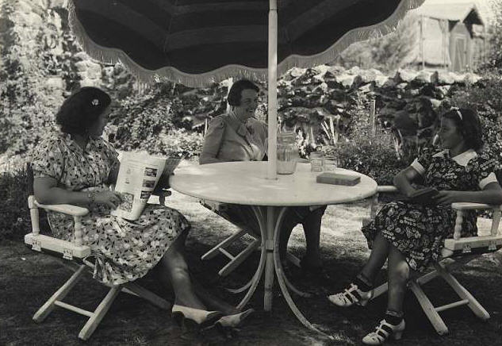
Velma, Della & Della – 1939

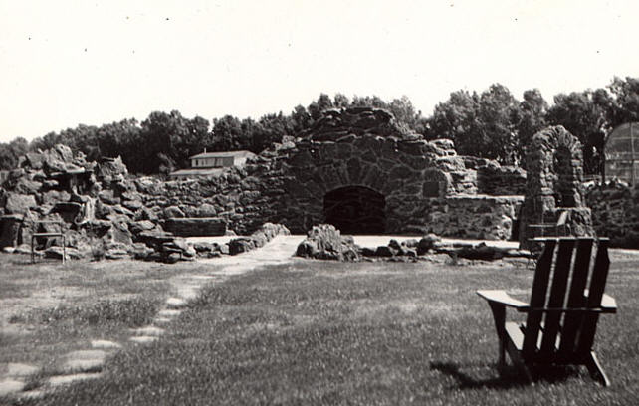
Fountain & Fireplace - 1940

